What can I purchase with my points?

9 Pts = Name Badge/Bible
18 Pts = Fidget spinner/Pen
26 Pts = SALT/other T-shirt
34 Pts = water bottle/devo
42 Pts = soccer ball/light-up shoelaces
48 Pts = Spring Overnight – May 12-13
54 Pts = Light-up bracelet/gloves
62 Pts = Ticket to Sunsplash
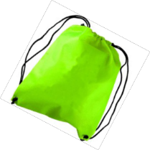
70 Pts = Flying ball/scrunchy/nail polish
80 Pts = Drawstring backpack/pop fidget
90 Pts = Mystery prize
Total Possible Points this semester = 94

How do I earn points?
Each week you can earn a total of 4 points.

1= Coming to class Wednesday night
1= Bringing your Bible

1= Knowing your weekly memory verse

1= Completing all the pages of your weekly devotional
